dysphagia nutrition & hydration bundle

**Dysphagia,**

**Nutrition and Hydration   
Bundle**

**The content of this document can be found on the intranet under**

**Version 1**

**January 2017**

|  |  |
| --- | --- |
| **Dr Elizabeth Boaden** | Clinical Lead - Speech and Language Therapist |
| **Sandra Wilkes** | Senior Speech and Language Therapist - NAG member |
| **Siobhan Ludlow** | Specialist Speech and Language Therapist |
| **Amy Holehouse** | Specialist Dietitian |
| **Charlotte Armstrong** | Specialist Dietitian - NAG Member |
| **Philippa Pordes** | Dignity Matron |
| **Angela Hewitt** | Endoscopy Nurse - NAG member |
| **Nutrition Advisory Group members**  **Dr Yoong (Chair)**  **Mrs C Bruce**  **Dr Alistair Martin**  **Phil Chilton**  **Ali Barnes**  **Helen Nutkins**  **Cathy Samsudin**  **Divya Kakkar** | Consultant Gastroenterologist  Consultant Surgeon  Consultant Anaesthetist  Senior Charge Nurse, Critical care  Matron (Emergency Care Division)  Modern Matron  Senior PN Pharmacist  Home Enteral Feeding Dietitian |
|  |  |

The multidisciplinary team involved in the creation of this document:

Contents

INTRODUCTION 4

DEFINITIONS 6

MACROPATHWAY FOR DYSPHAGIA, NUTRITION AND HYDRATION BUNDLE 7

CAPACITY 8

ASSESSMENT OF CAPACITY FORM 9

BEST INTERESTS CHECKLIST 12

EATING and DRINKING AT RISK FLOW PATHWAY 15

WHAT IS ASPIRATION? **Error! Bookmark not defined.**

EATING AND DRINKING AT RISK - INFORMATION FOR PATIENTS 16

EATING AND DRINKING AT RISK - INFORMATION FOR CARERS AND RELATIVES 17

EATING AND DRINKING AT RISK – LETTER TO GP 18

SPEECH AND LANGUAGE THERAPY FLUID RECOMMENDATIONS **Error! Bookmark not defined.**

SPEECH AND LANGUAGE THERAPY FOOD RECOMMENDATIONS 20

ORAL DESENSITISATION PROGRAMME 21

FLAVOUR PROGRAMME **Error! Bookmark not defined.**

NASOGASTRIC TUBE FEEDING (NGT) PATHWAY 26

IS NASOGASTRIC TUBE (NGT) FEEDING FOR ME? **Error! Bookmark not defined.**

NASOGASTRIC TUBE CHECKLIST 27

GUIDANCE ON OBTAINING AN ASPIRATE 29

PROBLEMS AND TROUBLESHOOTING 30

NPSA – GUIDANCE FOR PLACING NGTS 31

DAILY CARE MONITORING OF NASOGASTRIC TUBE FEEDS 32

PERCUTANEOUS ENDOSCOPIC GASTROSTOMY (PEG) PATHWAY 34

IS A PEG FOR ME? 34

PEG REFERRAL FORM 36

DAILY CARE MONITORING OF LONG TERM FEEDING TUBES (PEG/PEJ/RIG/JEJ) 39

TOTAL PARENTERAL NUTRITION 40

# INTRODUCTION

This document has been developed by an iterative process of stakeholder interviews and focus group meetings. The aim is to provide a clear decision making pathway to facilitate a cohesive multidisciplinary team approach and a clear method of communication to transition between acute, community, private and the voluntary health care sector, putting the patient at the centre of decision making.

Incident reports (2015-2016) confirm unacceptable waiting times for medical decisions to be made regarding nutrition and hydration (range 5-21days).

This Nutrition and Hydration Bundle provides a guide for professionals through the care pathway to facilitate the decision-making process to ensure an appropriate, efficient and timely decision with regards to nutrition and hydration management which is in the patient’s best interest. In order to achieve this it is recommended that the patient pathway and the supporting documentation is used for all patients with swallowing difficulties. However, the documentation may also be appropriate for use with other client groups where additional nutritional intervention is required e.g. liver disease.

Patients who are deemed to have an unsafe swallow and at risk of aspiration are not always placed nil by mouth (NBM). The publication by the Royal College of Physicians & British Society of Gastroenterology (2010) has highlighted the increasing evidence-base which suggests that clinically assisted nutrition and hydration is not always clinically or psychologically beneficial or ethically appropriate for some patients.

Even in cases where clinically assisted nutrition and hydration is appropriate, every adult patient has the right to decide about their own treatment, and it may be that the patient decides to continue with oral intake or ‘Eating and Drinking at Risk’, accepting the occurrence of aspiration and choking risks.

In cases where patients lack the capacity to make decisions related to their nutrition and hydration, decisions are made on their behalf. The decision will take into consideration the patient's previous beliefs and wishes, clinical evidence-base and quality of life. In some cases, a decision is made against clinically assisted nutrition and hydration. Good practice in decision-making towards the end of life is evidenced in the GMC (2010) publication, ‘*Treatment and care towards the end of life’.*

Anecdotal evidence suggests that decisions to ‘Eating and Drinking at Risk’ are being made regularly. However, there are often issues with these decisions including them not being made in a timely manner, relevant people not being involved (i.e. patient, family, professionals) and/or the decision not being appropriately documented.

**The Multidisciplinary Team**

The nursing staff remain responsible for patients eating and drinking. Although nursing staff may delegate eating and drinking tasks to other people, the responsibility remains with the nursing team. Any person giving the patient something to eat or drink must be made aware of the guidelines and modified consistencies for that patient and any compensatory strategies required.

‘Eating and Drinking at Risk’ decisions are the ultimate responsibility of the Consultant in charge of the patient’s care. If the Consultant is not immediately available, and in situations where all those involved are in agreement, this responsibility may be delegated to the multidisciplinary team. It should then be documented by a responsible clinician who has been involved in making the decision. If delegated, the Consultant must be informed at the earliest opportunity.

**Future Treatment**

Once an ‘Eating and Drinking at Risk’ decision has been made, it is often beneficial to discuss the potential of future complications and how these may be managed. Any decisions/guidance should be clearly documented in the medical notes. An example of this is whether or not a patient should be actively treated in the event of a chest infection.

**Discharge from hospital**

It is essential that any ‘Eating and Drinking at Risk’ decisions are communicated effectively to the patient’s primary carers and health professionals who will be involved in their care upon discharge from hospital. Some of the benefits of this include: consistency in the management of nutrition and hydration from hospital to home; support to those who are involved in feeding at the point of delivery, and avoidance of inappropriate hospital re-admission. Supporting documentation is available within this pathway.

**Documentation**

This Nutrition and Hydration Bundle documentation has been developed to provide a clear and efficient way of recording the decision that has been made. Completed forms should be filed in the medical notes.

All the documentation has been approved by the Nutrition Advisory Group, Information Governance, Operational Safety Effectiveness Group, the Patient Information Group, Nursing Documentation Group and the Nursing and Medical Directorates. Referral processes have been approved by Information Governance.

**References**

Enteral Nutrition Guidelines (2015) Mid Cheshire Hospitals <http://lhintra/trust-info/policies-guidelines-sops-and-pathways/policies-and-sops-download-page/?q=enteral> [accessed 11/08/16]

General Medical Council (2010) Treatment and Care towards the End of Life: Good Practice in Decision Making.

NHS improvement (2016) Resource set: initial placement checks for nasogastric and orogastric tubes.

Parental Nutrition Guidelines (2015) Mid Cheshire Hospitals <http://lhintra/trust-info/policies-guidelines-sops-and-pathways/policies-and-sops-download-page/?q=parenteral> [accessed 11/08/16]

Royal College of Physicians & British Society of Gastroenterology (2010) Oral Feeding Difficulties and Dilemmas: A Guide to Practical Care particularly towards the End of Life.

# DEFINITIONS

**Speech and Language Therapy (SLT)**

Speech and language therapists (SLT) assess and treat people who have eating, swallowing and communication difficulties.

**Dietitian**

Registered dietitians are qualified health professionals who assess, diagnose and treat diet and nutrition problems at an individual and wider public health level.

**Capacity**A person lacks capacity if their mind is impaired or disturbed in some way, and this means the person is unable to make a decision at that time. The Mental Capacity Act states that a person is unable to make a decision if they cannot: understand the information relevant to the decision; retain that information; use or weigh up that information as part of the process of making the decision. In these situations, decisions may be made in the patient’s ‘best interests’. Capacity can fluctuate with time – an individual may lack capacity at one point in time, but may be able to make the same decision at a later point in time.

**Swallowing**

The act of deglutition from placement of food in the mouth through the pre-oral, oral and pharyngeal stages of the swallow until the material enters the oesophagus through the cricopharyngeal juncture.

**Dysphagia**

Eating and drinking disorders that may occur in the oral, pharyngeal and oesophageal stages of deglutition.

**Aspiration**

The entry of food and/or fluid into the airway below the level of the vocal folds.

**Clinically assisted nutrition and hydration** The provision of nutrition and hydration via enteral or parenteral means, for example nasogastric tube (NGT), percutaneous endoscopic gastroscopy (PEG), radiologically inserted gastrostomy (RIG), jejunostomy (JEJ), Total Parenteral Nutrition (TPN).

**Hydration**

The provision of hydration via enteral or parenteral means, for example intra-venous access, sub-cutaneous access, nasogastric tube.

**Nasogastric tube (NGT)**

A nasogastric tube is a narrow bore tube passed into the stomach via the nose to provide nutrition and hydration when oral intake is inadequate or unsafe. This route is usually short-term.

**Percutaneous endoscopic gastroscopy (PEG)**

A percutaneous endoscopic gastrostomy (PEG) is a tube that is passed into the patient’s stomach through the abdominal wall to provide a long-term means of nutrition and hydration when oral intake is inadequate or unsafe. A PEG tube is usually placed via endoscopy.

**Total parenteral nutrition (TPN)** is a method of intravenous feeding that bypasses the gastrointestinal tract. Fluids are given into a vein to provide most of the nutrients the body needs.

**Eating and Drinking at Risk**  
A decision made to provide a patient with oral intake (nutrition, hydration and medication) despite a high risk of aspiration, where compensatory strategies may reduce but will not eliminate the risk. This decision may be made by the patient or in their best interests if they lack capacity.

# MACROPATHWAY FOR DYSPHAGIA, NUTRITION AND HYDRATION BUNDLE

**MACROPATHWAY for DYSPHAGIA, NUTRITION AND HYDRATION BUNDLE   
for patients who have difficulties with swallowing, nutrition and hydration**

**CAPACITY  
(See Section A)** **YES**  **NO**  
Discussion with patient re: preferred management Best Interests decision

**PERCUTANEOUS ENDOSCOPIC GASTROSTOMY FEEDING   
(PEG)**

**(See Section D)**

**EATING and DRINKING AT RISK   
(EDAR)**

**(See Section B)**

**TOTAL PARENTERAL NUTRITION (TPN)**

**(See Trust Guidelines)**

**NASOGASTRIC  
TUBE FEEDING   
(NGT)**

**(See Section C)**

**DECISION (Please tick box):**

**EATING and DRINKING AT RISK (Patient capacity and choice or medical decision made**

**in patient’s best interests)**

**EATING and DRINKING AT RISK (Patient at End of Life)**

**NASO-GASTRIC TUBE FEEDING (If time trial – length :______________________)**

**PERCUTANEOUS ENDOSCOPIC GASTROSTOMY FEEDING (PEG)**

**TOTAL PARENTERAL NUTRITION (TPN)**

**Signature:**

**Designation: Date:**

**Complete a new form if there is a change in patient management and   
FILE THIS FORM IN THE MEDICAL NOTES**

**CAPACITY  
(Section A)**

**DOCUMENTATION within this section:**

Capacity

Best Interests Checklist

# CAPACITY

## ASSESSMENT OF CAPACITY FORM

*Please ensure that capacity assessments are also completed for those found to have capacity to make the decision, where there may be concerns raised as to the cognitive abilities of the person.

Patient Name: __________________ DOB: ___________ NHS No: ________________

Address: _______________________________________________________________

|  |
| --- |
| **Clinician(s) Completing Assessment of Capacity:**  Name Job Title Date of Assessment |
| **What Are The Reasons That Lead You To Think The Person Has Impaired Capacity?** |
| **Reason for Assessment of Capacity:** |
| **Enhancing Capacity:**  Where did this assessment take place? Please specify:  Was the environment free from noise and other distractions? Please specify:  Have issues relating to timing of the assessment been considered eg first thing in the morning or at lunchtime when hungry? Please specify:  Are there any recent life events that may contribute to the person’s capacity? Please specify: |

|  |
| --- |
| Has the person recently taken any form of medication that is likely to impact on their capacity?  Please specify:  Have relevant health and social care professionals, families and carers been consulted regarding this person’s capacity? Please specify: |

|  |
| --- |
| **Assessment of Capacity:**  Stage 1 – Diagnosis:  Does the patient have an impairment of, or disturbance in, the functioning of the mind or brain? □ Yes □ No  If yes, is the impairment: □ Temporary □ Fluctuating □ Permanent  If temporary/fluctuating, can the decision wait until capacity returns? If not please provide details:  Stage 2 – Functioning:  If yes to the above question, is the patient able to:  Understand the information relevant to the decision? □ Yes □ No  Evidence – include the actions taken to enhance capacity:  AND:  Retain that information? □ Yes □ No  Please provide details/further information if appropriate/necessary:  AND:  Use or weigh that information as part of the process of making the decision**? □** Yes □ No  AND/OR:  Is the patient able to communicate their decision whether by talking, using sign language or other means?  **□** Yes □ No  Please provide details/further information if appropriate/necessary: |

**Decision Regarding Capacity:**

As a result of the above, I consider the patient has* or does not have* capacity to make this decision. (*Delete as appropriate).

**Decision Maker:**

Signed: ____________________________ Job Title: ____________________________________

Name (in capitals): ________________________________________ Date: ____________________

*If the patient is assessed as* ***not having capacity to make this decision,*** *you must consider the Best Interest’s Checklist before deciding what is in the patient’s best interests.*

|  |
| --- |
| **Summary:** |

## BEST INTERESTS CHECKLIST

|  |  |  |  |  |  |  |  |  |  |  |  |
| --- | --- | --- | --- | --- | --- | --- | --- | --- | --- | --- | --- |
| Patient Name: | |  | | DOB: |  | NHS No: | |  | | | |
| Address: |  | | | | | | | | | | |
|  | | | | | | | | | | | |
| (Patient Name) …………………..…...……… was assessed on (date) …………………………… by (clinician) ………………………… as not having capacity in relation to making a decision about ……………………………………………………………………………… The Best Interests Checklist will now be completed before deciding what is in the person’s best interest. | | | | | | | | | | | |
|  | | | | | | | | | | | |
| **Best Interests Checklist:** | | | | | | | | | | | |
| 1. I have encouraged and assisted the patient to participate in the decision. | | | | | | | | | | | ❑ |
| 1. I have considered all factors relevant to the decision. | | | | | | | | | | | ❑ |
| 1. I have attempted to find out the views of the patient, including their past and present wishes and feelings and taken these into account. | | | | | | | | | | | ❑ |
| 1. I have not based my assessment solely on the patient’s age, appearance, condition or behaviour. | | | | | | | | | | | ❑ |
| 1. I have considered whether the patient might regain capacity and if so whether the decision can be delayed. | | | | | | | | | | | ❑ |
| 1. If physical intervention is required use GP letter to clarify underlying physical conditions. | | | | | | | | | | | |
| Please provide details of how you have applied factors 1-6 and what factors have been taken into account: | | | | | | | | | | | |
| 1. Has the patient made a relevant applicable Lasting Power of Attorney? If yes, the attorney may be able to provide consent. ❑ Yes ❑ No | | | | | | | | | | | |
| 1. Has the patient made a valid applicable Advance Decision refusing the treatment concerned? If yes, the Advance Decision should be respected (in case of uncertainty, further guidance should be sought). ❑ Yes ❑ No | | | | | | | | | | | |
| Details: | | | | | | | | | | | |
| 1. I have consulted the patient and the relevant individuals in coming to my decision and their views are: | | | | | | | | | | | |
| Name | | | Title/Role | Views | | | | | | | |
|  | | |  |  | | | | | | | |
| 1. For the following reason(s) it was not practicable/appropriate* (*delete as appropriate) to consult: | | | | | | | | | | | |
| Name | | | Title/Role | Reason(s) | | | | | | | |
|  | | |  |  | | | | | | | |
| 1. Any Dissenting opinion(s) are shown below. | | | | | | | | | | | |
| Name | | | Title/Role | Dissenting Opinion | | | Action to Resolve | | | | |
|  | | |  |  | | |  | | | | |
|  | | | | | | | | | | | |
| **Independent Mental Capacity Advocate Service:** | | | | | | | | | | | |
| * A referral to the IMCA Service is not necessary as: | | | | | | | | | | | |
| * + I have been able to consult relevant individuals under the Best Interests Checklist. | | | | | | | | | ❑ | | |
| * + The decision needs to be taken on an urgent basis. | | | | | | | | | ❑ | | |
| Reason for urgency: | | | | | | | | | | | |
| * A referral has been made to the IMCA Service and I have taken the IMCA’s view into account (attach the IMCA’s written view). | | | | | | | | | ❑ | | |
|  | | | | | | | | | | | |
| **Life Sustaining Treatment:** | | | | | | | | | | | |
| My decision is not motivated by a desire to bring about the patient’s death. | | | | | | | | | | | |
|  | | | | | | | | | | | |
| **Deprivation of Liberty Safeguards (DOLS):** | | | | | | | | | | | |
| Due consideration has been given regarding restrictions and deprivation. | | | | | | | | | | ❑ | |

**EATING and DRINKING AT RISK  
(EDAR)  
*If the patient is suitable for Eating and Drinking at Risk complete the Macropathway form, tick the decision box, sign and file in the medical notes*   
  
(Section B)**

**DOCUMENTATION within this section:**

Eating and Drinking at Risk Flow Pathway

What is Aspiration?

Eating and Drinking at Risk – Information for Patients

Eating and Drinking at Risk – Information for Carers and Relatives

Eating and Drinking at Risk – Letter to GP

Speech and Language Therapy FLUID Recommendations

Speech and Language Therapy FOOD Recommendations

Oral Desensitisation Programme

Flavour programme

# EATING and DRINKING AT RISK FLOW PATHWAY

**EATING AND DRINKING AT RISK (EDAR) PATHWAY**

Unsafe swallow (from SLT Assessment)

Capacity (Section A)

Unsafe swallow (from SLT Assessment)

**Patient has capacity and chooses to ‘Eat and Drink at Risk’**

**Provide patient with documentation re:**  
What is Aspiration?

Eating and Drinking at Risk – Information for Patients

Speech and Language Therapy FLUID Recommendations (optional)

Speech and Language Therapy FOOD recommendations (optional)

**Provide carers with documentation re:**  
Eating and Drinking at Risk – Information for Carers and Relatives

**Provide letter to GP re:**   
Eating and Drinking at Risk – Letter to GP

Medical team to document decision in medical notes

**Patient does not have capacity   
Consider:**i) patient’s previous wishes, advanced decisions or directives ii) patient diagnosis   
iii) level of alertness and distress when eating and drinking  
iv) best practice Guidelines e.g. NICE, RCP, GMC)

**Discuss with the patient, family and MDT** (e.g. SLT, Dietitian, Nursing staff, IMCA)

**Provide patient and carers with documentation re:**  
What is Aspiration?

Eating and Drinking at Risk – Information for Patients

Eating and Drinking at Risk – Information for Carers and Relatives

Speech and Language Therapy FLUID Recommendations

Speech and Language Therapy FOOD Recommendations

**Provide letter to GP re:**   
Eating and Drinking at Risk – Letter to GP

Medical team to document decision in medical notes

**Patient is in the last few days of life/Fast track home   
(please see End of Life Care pathway for guidance)**

Allow oral intake as per patient preferences

Offer non-distressing consistencies

Provide regular oral care for comfort

Flavour programme as per patient preference

**Provide patient, family or carers with:**Eating and Drinking at Risk – Information for Patients

Eating and Drinking at Risk - Carers and Relatives

Flavour programme

**Provide letter to GP re:**   
Eating and Drinking at Risk – Letter to GP

Medical team to document decision in medical notes

**WHAT IS ASPIRATION?**

**INFORMATION FOR PATIENTS, CARERS AND RELATIVES**

This information is available in audio, Braille, large print and other languages.   
To request a copy, please ask a member of staff.

Reviewed by Readers’ Panel October 2016.   
  
Printed December 2016 Review December 2018 Ref: DCS/SLT/0011216

Date leaflet given:

Discussed with:

Designation:

Patient sticker:

You need 26 pairs of muscles and 6 nerves to work together to move food, drink and medication from your mouth across your airway and down into the tube to your stomach.

If you have swallowing problems, food, drink and medication may go into your lungs (which is called ‘aspiration’) and may cause a chest infection. Chest infections can cause scarring to the lungs and as the frequency of chest infections increase it is more difficult to recover from them.

Some people cough, become short of breath, have a wet voice quality, or feel something ‘catch’ in their throat. Other people have no symptoms at all.

The picture below shows food bolus (green) going into the esophagus (food pipe), but some food bolus also spilling into the trachea (airway).

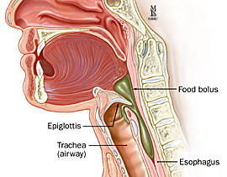

**Aspiration of food bolus into the trachea (airway)**

**EATING AND DRINKING AT RISK**

**INFORMATION FOR PATIENTS**

Difficulties in swallowing can put a person at increased risk of choking and/or developing a chest infection because there is a chance food and drink can go down ‘the wrong way’ into the lungs instead of the stomach.

The term ‘Eating and Drinking at Risk’ is used when a decision is made to eat and drink, accepting that choking episodes or repeated chest infections may occur. This decision is usually made when clinically assisted nutrition and hydration are not appropriate or acceptable. The decision to Eat and Drink at Risk needs to be decided by yourself, the doctor and hospital team. You may also wish to discuss it with your family.

When you are eating and drinking you may find that you:

* Cough and choke
* Have a wet, gurgly voice or wet breath sounds
* Feel short of breath
* Suffer from recurrent chest infections/pneumonia

You may be assessed by a Speech and Language Therapist (SLT) who will provide you with advice to help make eating and drinking as easy as possible. The SLT may:

1. advise you how to modify the consistency of food and drink so that you have the consistencies that are least likely to cause food and drink to go onto the lungs
2. advise you on consistencies that are least distressing if all consistencies are going onto the lungs
3. advise you to eat and drink according to your personal preferences

If you have already been assessed, the following recommendations have been made:   
(SLT to insert diet and fluid consistency recommendations)

There may be instances when eating and drinking is more difficult or distressing for you. If you feel uncomfortable then stop eating and drinking and try again later. You may wish to talk to your doctor if distress persists, your health deteriorates or you wish to change your mind about ‘Eating and Drinking at Risk.’

**Your GP has been made aware of your ‘Eating and Drinking at Risk’ decision and is the point of contact for further management after your discharge from hospital**.

**Please note**: Further Speech and Language Therapy involvement will be at the discretion of the health professionals involved but is unlikely to be of significant benefit. Reasons for further involvement may be linked with significant improvement or significant change in your medical condition that are likely to affect the swallowing function.

**This information is available in audio, Braille, large print and other languages.   
To request a copy, please ask a member of staff.**

Reviewed by Readers’ Panel October 2016.

Printed December 2016 Review December 2018 Ref: DCS/SLT/0021216

**EATING AND DRINKING AT RISK**

**INFORMATION FOR CARERS AND RELATIVES**

This patient is ‘Eating and Drinking at Risk’. Difficulties in swallowing can put a person at increased risk of choking and chest infections because food and drink are aspirated onto the lungs instead of moving to the stomach. The term ‘Eating and Drinking at Risk’ is used when a decision is made to allow a person to continue to eat and drink, accepting that they may suffer from choking episodes or repeated chest infections. This decision is usually made when clinically assisted nutrition and hydration are not appropriate or to help maintain a person’s quality of life.

It has been agreed by the multidisciplinary team that the patient will continue to eat and drink, accepting the risks of aspiration. The patient should have an ‘Eating and drinking at Risk’ decision documented in their medical records. In order to maintain comfort and ease whilst eating and drinking, the patient has been assessed by a Speech and Language Therapist and the following recommendations have been made:

(SLT to insert diet and fluid consistency recommendations)

When eating and drinking they may experience any of the following:

* coughing
* choking
* colour change in their face
* a wet, gurgly voice or wet breath sounds
* shortness of breath after eating and drinking
* recurrent chest infections/pneumonia
* high temperatures

If you observe any of the above symptoms then you may wish to stop offering food and drink and try again later. There may be instances where food and drink are no longer accepted or tolerated by the patient or the patient’s health deteriorates. It may be appropriate to take no further action, but this will need to be discussed with the patient’s doctor.

**The GP will be made aware of the ‘Eating and Drinking at Risk’ decision and is the point of contact for further management once the patient has been discharged from hospital.**

**Please note**: Further Speech and Language Therapy involvement will be at the discretion of the Health Professionals involved but is unlikely to be of significant benefit. Reasons for further involvement may be linked with significant improvement or significant changes in the patient’s medical condition that are likely to affect the swallowing function.

This information is available in audio, Braille, large print and other languages.   
To request a copy, please ask a member of staff.

Reviewed by Readers’ Panel October 2016.

Printed December 2016 Review December 2018 Ref: DCS/SLT/0031216

## EATING AND DRINKING AT RISK – LETTER TO GP

Speech and Language Therapy Department  
Leighton Hospital  
Middlewich Road  
Crewe CW1 4QJ  
Direct Dial: 01270 612342  
Date:

Dear Dr

Re: Name:  
Address:  
DOB:   
NHS Number:

During their hospital admission this patient was assessed by the Speech and Language Therapy team who felt that there were indications of airway compromise across all consistencies trialled. This was felt to be linked with the patient’s underlying medical diagnosis and is not expected to improve.

In light of the patient’s difficulties, a decision was made by the multidisciplinary team to continue ‘Eating and Drinking at Risk’ accepting the risk of aspiration.

With this decision, it is possible that this patient’s nutrition, hydration and chest status may be compromised. The patient and carers have been advised to contact their GP for any further management on discharge from hospital.

Further Speech and Language Therapy intervention is not likely to be beneficial. Current ‘Eating and Drinking at Risk’ recommendations are:

The following recommendations have been made:

**Delete where appropriate**:   
I would therefore be grateful if you could please prescribe Resource Thicken Up Clear PIP code 355-4433 at the following average quantities:

* 4 x tins per month for syrup thick
* 8 x tins per month for custard thick
* 12 x tins per month for pudding thick

Please contact me if you require any further details regarding this patient’s recommendations.

Yours sincerely,

Speech and Language Therapist

**SPEECH AND LANGUAGE THERAPY FLUID RECOMMENDATIONS   
INFORMATION FOR PATIENTS, CARERS AND RELATIVES**

When people have difficulties with their swallowing, they are often advised to have modified fluids. This often means that they need to add thickener to their drinks in order to swallow safely. The nursing staff will inform you of the required thickness when you are discharged from hospital. This leaflet should be able to provide you with some extra guidance.

In order to avoid lumps, put the thickener in the cup first, then add the liquid and stir briskly allowing time for the liquid to thicken. Always use a scoop to measure the powder (not a spoon). Never add more or less powder than the prescribed amounts. The powder may be used to thicken any drinks, soups or gravy but cold drinks mix better than hot ones. Strong flavours and chilled drinks seem to be more palatable however dairy products do not mix very easily. Thickener is available on prescription.

**Top Tips**

[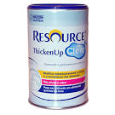](http://www.google.co.uk/url?url=http://www.ultrafitness.com.br/produto/detalhes-334/resource-thicken-up-clear-125g-nestle-nutrition.html&rct=j&frm=1&q=&esrc=s&sa=U&ei=lkcQVcisJsTeONCvgNAE&ved=0CCQQ9QEwBw&usg=AFQjCNEDgmiCpJ1q33oJSHpAzddtBkE7tg)  
**Slightly thick (Naturally thick) fluids - 1:   
0.5 (half) scoop of Resource Thicken Up ClearTM per 100mls of fluid.**



This consistency should leave a coating on an empty glass.

**Mildly thick (Syrup) fluids - 2:   
1 flat scoop of Resource Thicken Up ClearTM per 100mls of fluid.**

This consistency should leave a thin coating on the back of a spoon, similar to runny honey, pourable and can be drunk from a cup.

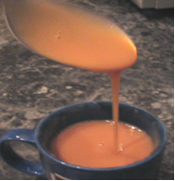

**Moderately thick (Custard) fluids - 3:   
2 flat scoops** **of Resource Thicken Up ClearTM per 100mls of fluid.**

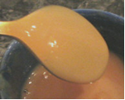

This consistency leaves a thick coating on the back of a spoon. Similar to a thick smooth yoghurt and can be taken by spoon.

[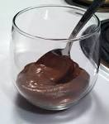](https://www.google.co.uk/url?url=https://cookingallergyfreewitheoe.wordpress.com/&rct=j&frm=1&q=&esrc=s&sa=U&ei=bUUQVcLKIYzWPKnLgMAC&ved=0CCAQ9QEwBTigAQ&usg=AFQjCNGf5BR5ZR82DDudBDks-TphjmLxhg)**Extremely thick (Pudding) fluids - 4:   
3 flat scoops** **of Resource Thicken Up ClearTM per 100mls of fluid.**

This consistency would hold its shape on the spoon.

Reviewed by Readers’ Panel October 2016. Available in other formats on request.

Printed December 2016 Review December 2018 Ref: DCS/SLT/000041216

**SPEECH AND LANGUAGE THERAPY FOOD RECOMMENDATIONS**

**INFORMATION FOR PATIENTS, CARERS AND RELATIVES**

When people have difficulties with their swallowing, they are often advised to have modified food. This often means that they need to modify their food in order to swallow safely. The nursing staff will inform you of the required modification when you are discharged from hospital. This leaflet should be able to provide you with some extra guidance.

**:**

**Liquidised food - 3 (Texture B):**This should be a thin smooth texture that has been pureed and sieved. It should have no lumps and should be eaten with a spoon. It will not hold its shape on the spoon.

**Puree food – Texture C:**

[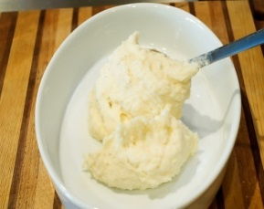](http://www.flickr.com/photos/pioneerwoman/1834668151/)

**Pureé food - 4 (Texture C):**

This should be a thick smooth texture that has been pureéd and sieved. It should have no lumps and should be eaten with a spoon or a fork. It will hold its shape on the spoon and can be moulded. Examples: pureéd vegetables, meat pureed with sauces or gravy, thick custard, yoghurt.

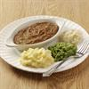

**Minced and Moist food - 5 (Texture D):**

Food is mashed with a fork before serving. It can be served in a very thick sauce or gravy, requires very little chewing. Meat should be pureéd and fish can be mashed. Examples: mashed potatoes, mashed fish in sauce, mashed vegetables.

**[](http://greentrack.co.uk/sumiglass/wp-content/gallery/portfolio/292882.jpg)**

**Soft and bite sized food - 6 (Texture E):**

Soft, moist, easy chew food that can be mashed with a fork. Example: sponge cake, casseroles (small pieces of tender meat), slightly overcooked vegetables. **Bread, sandwiches and toast should be avoided unless specifically agreed with the Speech and Language Therapist.** No high risk foods (see below).

**High risk food**

As we chew, the food is broken down into a single consistency, which we are then able to swallow. Our tongues help to separate out consistencies in order that we can swallow one consistency at a time. Some consistencies cannot be broken down and may cause some people to choke. You may be advised to avoid high risk foods. Examples: stringy fibrous texture (pineapple, runner beans, celery, lettuce); vegetable and fruit skins (broad beans, baked beans, soya beans, black-eyed peas, grapes); mixed consistency foods (cereals that do not blend with milk, mince with thin gravy, soup with lumps); crunchy foods (biscuits, crisps, flaky pastry); hard foods (boiled and chewy sweets, nuts and seeds, tough meat); husks (sweetcorn, granary bread).

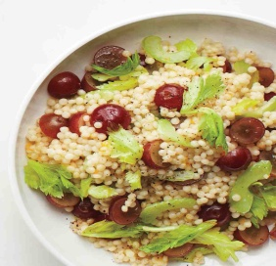

This information is available in audio, Braille, large print and other languages. To request a copy, please ask a member of staff.   
  
Reviewed by Readers’ Panel October 2016.   
  
Printed December 2016 Review December 2018 Ref: DCS/SLT/0051216

**ORAL DESENSITISATION PROGRAMME**

**INFORMATION FOR PATIENTS, CARERS AND RELATIVES**

**This will be adapted for each patient by the Speech and Language Team**

**What is oral desensitation?**

The strategies and advice in this oral desensitisation programme are designed to improve oral comfort and oral health, thereby improving quality of life; decrease oral sensitivity or prevent orally defensive patterns emerging, improve tongue movement and may support long term rehabilitation of swallowing function.

Some of the activities shown in this leaflet provide sensation to the mouth. Therefore it may be appropriate to include this programme as part of the person’s oral hygiene routine.

Different people demonstrate different degrees of sensitivity in different parts of the face and mouth, so be guided by the healthcare professional and by the individual’s response when undertaking the programme.

**What is the programme?**

Activities should be carried out on a daily basis as this will usually be most effective in developing tolerance to sensations in the mouth.

**1. Always make sure the person is positioned appropriately, is supported and has postural stability.**

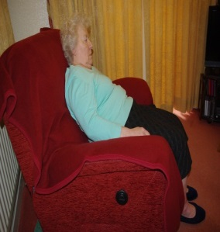 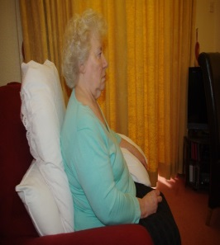 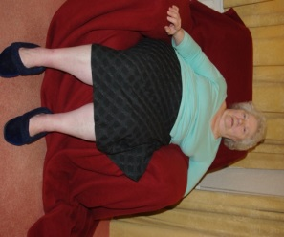 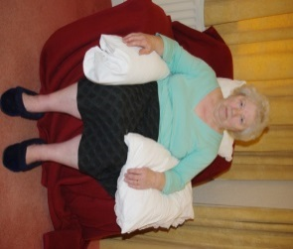

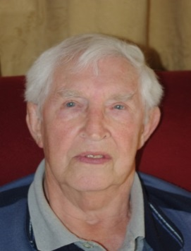**2. Facial hypersensitivity may be shown by facial grimacing, moving the face away from touch or becoming more agitated. Follow the arrows in the picture, moving the hands towards the mouth. The following activities may help to alter sensitivity in the oral cavity.**

**3. Place a finger on the lips and rub along the lips**

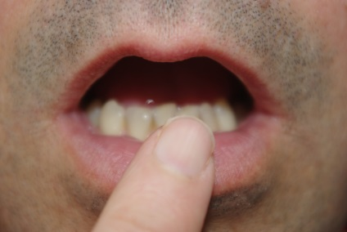

**4. Roll the finger inside the lips**

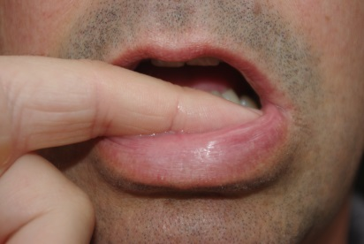

**5. Rub the finger along the gum surface**

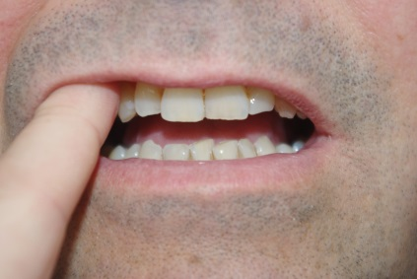

**6. Introduce a stimulus to the tongue: wipe the finger or back of a spoon over the tongue surface. Try different textures and temperatures. You should try to improve tolerance to each different stimulus slowly. It is important that the person’s tolerance to textures and oral motor skills are developed at a comfortable pace – be patient, be guided by the individual and the healthcare professional**

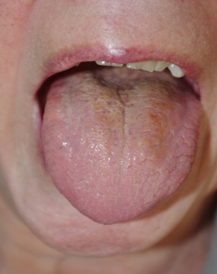

This information is available in audio, Braille, large print and other languages.   
To request a copy, please ask a member of staff.   
Reviewed by Readers’ Panel October 2016.   
Printed December 2016 Review December 2018 Ref: DCS/SLT/0061216

**FLAVOUR PROGRAMME**

**INFORMATION FOR PATIENTS, CARERS AND RELATIVES**

**This will be adapted for each patient by the Speech and Language Team**

**Background**

Some people have difficulty swallowing; as a result, food and drinks may go into the lungs instead of into the stomach. They are therefore given food and drink via an alternative method. The mouth and tongue may become dry or sore or they may just prefer to have a different flavour in their mouths.

Giving people food or drink to swallow from a spoon may cause a chest infection but having a very small amount of flavour spread on the tongue may improve oral comfort and improve their quality of life.

**Programme**

**Dip a spoon into a liquid and wipe the BACK of the spoon over the tongue**

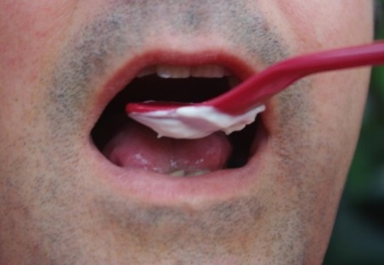 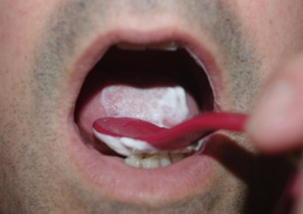 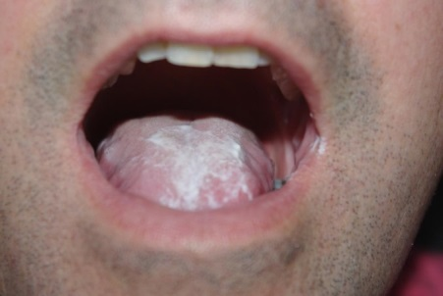

Sometimes a slightly thicker fluid such as a smoothie, will stick to the spoon better.

Try small amounts of lemon or grapefruit juice on a cotton swab or the back of a small spoon. Whilst the combination of the cold temperature and sour taste often provide greater stimulation of the oral cavity but you should always choose the flavours that the individual prefers.

This information is available in audio, Braille, large print and other languages.   
To request a copy, please ask a member of staff.   
  
Reviewed by Readers’ Panel October 2016.

Printed December 2016 Review December 2018 Ref: DCS/SLT/0071216

**NASOGASTRIC  
TUBE FEEDING   
(NGT)  
*If the patient is suitable for NGT complete the Macropathway form, tick the decision box, sign and file in the medical notes*  
  
(Section C)**

**DOCUMENTATION within this section:**

Nasogastric tube feeding pathway

Is Nasogastric tube feeding for me? – Information for Patients

Nasogastric Tube Documentation

Guidance in gaining an aspirate

Problems and Troubleshooting

NPSA Guidance for placing an NGT

Daily care monitoring of Nasogastric tube feeds

# NASOGASTRIC TUBE FEEDING (NGT) PATHWAY

**NASOGASTRIC TUBE FEEDING (NGT) PATHWAY**

Patient has an acute deterioration of swallow function OR has deterioration in nutrition that could benefit from an NGT **OR** would benefit from a time trial of NGT feeding?

**YES NO**

- Provide patient/family/carers with   
 documentation: Is Nasogastric Tube feeding  
 for me?  
- Contact dietitian   
- Document time trial period if appropriate   
- Complete NGT Checklist and file in medical  
 notes  
- Continue regular oral care  
- Contact SLT for flavour programme   
 consideration  
- Refer to Trust Enteral Feeding Guidelines

Patient is not medically fit or has other medical contra-indications

Ensure ‘Eating and Drinking at Risk’ pathway (Section B) is followed and documented in the medical notes

Time trial complete   
Refer to SLT for further swallow assessment

**Time trial complete  
 swallow function has not improved**

Best interests meeting to decide care plan (with patient, family, carers, relevant members of MDT) to discuss:  
- Extending trial  
- Remove NGT and   
 commence Eating and   
 Drinking at Risk   
 (Section B)  
- End of life care   
 (Section B)  
- Long term clinically   
 assisted nutrition and   
 hydration (Section D)

Document results of best interests meeting

**Time trial complete  
 swallow function has improved**

Introduction of oral intake managed by MDT

**Patient is not tolerating NGT**

Contact dietitians  
3 x NGT attempts  
  
Consultant to consider:  
- DOLS (inform dignity   
 matron)  
- NGT with bridle/mittens  
- Eating and Drinking at   
 Risk (Section B)  
- End of life care (Section   
 B)  
- Long term clinically   
 assisted nutrition and  
 hydration (Section D)  
- Best interests meeting  
 to decide care plan with  
 patient, family, carers,  
 relevant members of  
 MDT

Document results of best interests meeting

**IS NASOGASTRIC TUBE (NGT) FEEDING FOR ME?**

**INFORMATION FOR PATIENTS, CARERS AND RELATIVES**

You need 26 pairs of muscles and six nerves to work together to move food, drink and medication from your mouth across your airway and down into the tube to your stomach.

**What is a nasogastric tube (NGT)?**

A Nasogastric Tube (NGT) is a small, thin, flexible tube that is passed into the stomach via the nose, to provide an alternative route to provide nutrition (food and fluid). The initial placement of an NGT can be uncomfortable and many people describe a ‘scratching’ feeling at the back of their throat. Once the metal guidewire is removed from the centre of the tube, the tube becomes much softer and easier to tolerate.

**Why do I need a nasogastric tube (NGT)?**

If you have swallowing problems, food, drinks and medication may go into your lungs and possibly cause a chest infection. A chest infection can cause scarring to the lungs and if you suffer from re-occurring chest infections, over time you may find it becomes more difficult to recover. Some people cough, become short of breath, have a wet voice quality or feel something ‘catch’ in their throat. Other people have no physical symptoms at all.

If you are suffering from a chest infection and are struggling with breathing when eating, an NGT can provide you with adequate nutrition, whilst also allowing your chest time to recover. NGTs are also used to provide adequate nutrition if you have an unsafe swallow or if your oral intake is poor. NGT feeding is usually temporary and used for weeks rather than months.

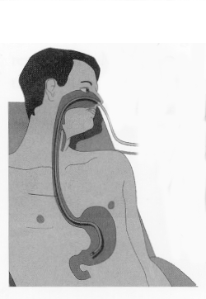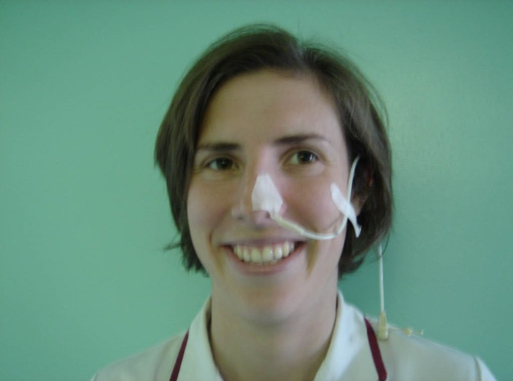If you have problems with your swallow, prescribed nutrition and fluids and medicine can be provided via the NGT. The Dietitian will assess your need for nutrition and fluid via the NGT and advise what you will need to meet your nutritional requirements. If you are able to have some food or drink in addition to the NGT, the Speech and Language Therapist will advise you on this.

Nasogastric tube

Stomach

## 

This information is available in audio, Braille, large print and other languages.   
To request a copy, please ask a member of staff.

Reviewed by Readers’ Panel October 2016.   
Printed December 2016 Review December 2018 Ref: DCS/SLT/0081216

|  |  |  |  |  |  |  |  |
| --- | --- | --- | --- | --- | --- | --- | --- |
| **Ward** | | | | | | | |
| This checklist should be completed for   * All patients requiring tube placement, on initial insertion and for all subsequent insertions * Before and after administration of artificial nutrition via the nasogastric tube. * Before and after administration of medication via the nasogastric tube. | | | | | | | |
| **Patient details** (Place patient sticker here) | | | | **Clinical Indication for Nasogastric Tube** | | | |
| **Type of Tube and size** | | | |
| **Date and time of insertion** | | | |
| **Nostril Used**  Left/Right | **NEX measurement in cm** | | | **Position at nostril once secured (cm)** | | **Bridle placed**  Yes/no | |
| **Aspirate obtained?**  YES/NO  pH result (safe range1-5.5)  If unable to obtain aspirate in safe range see **Problems and Troubleshooting** | | | | **Signature and designation of person inserting Nasogastric tube** | | | |
| **If an X-Ray is required to confirm position of the Nasogastric Tube, complete this section** | | | | | | | |
| **X-ray to check position of tube requested?**  YES/NO | | **Name of person authorising X-ray:** | | | **Patient prepared for X-ray ?**  YES/NO  (Chest & upper abdomen clear of all wires & leads) | | |
| http://2.bp.blogspot.com/_vT13IccOEqM/THwBw0-8GDI/AAAAAAAAACI/BokqnE30wvo/s1600/normal+lung.jpg**X-ray is the most current for the correct patient:**  YES/NO  **Name of trained person interpreting X-ray:**  **X-Ray confirmation of placement:**  YES/NO  **Draw on position of Nasogastric Tube**  **as well as any other tubes/wires present.** | | | | | **Does the NGT**:  Follow path of oesophagus: YES/NO  Bisect the carina or bronchi: YES/NO  Cross midline of diaphragm: YES/NO  Have its tip visible below  the left hemi-diaphragm: YES/NO  **SAFE TO USE: YES / NO** | | |
| Name of person checking X-ray: | | | Signature & Designation: | | | | Date: |

**NASOGASTRIC TUBE CHECKLIST**

**COMPLETE AND FILE IN MEDICAL NOTES**

## GUIDANCE ON OBTAINING AN ASPIRATE

|  |  |
| --- | --- |
| **If unable to obtain an aspirate:** | **If pH of aspirate ≥6.0 obtained:** |
| **If unable to gain an aspirate- undertake**  **the following actions in the order listed:**   * Draw slowly back with the plunger- it can take some time, be patient. Please be prepared to spend 5 minutes obtaining an aspirate from a fine bore feeding tube.   **IF unable to obtain an aspirate after 5 minutes:**   * Ask the patient to take a drink (ONLY if they have a safe swallow and are not NBM) If patient NBM, perform oral hygiene- this stimulates gastric secretions. * If able- turn the patient onto their left side * Flush the tube with 10-20mls of air, this will move the tube away from the stomach wall   Repeat process. Please make at least 2 attempts to aspirate tube before considering x-ray. | **If an aspirate with a pH of 6.0 or above is**  **obtained, see below:**  If the patient is receiving:   1. Antacids e.g. Gaviscon, Rennie. 2. H2 antagonists e.g. Ranitidine. 3. Proton Pump Inhibitors (PPI’s) e.g.   Lansoprazole, Omeprazole.  **If you find they may have an unusually  high gastric pH:**   * Retry aspirate later (consider doing prior to next dose of medications) as more likely to get an acidic pH (1-5.5)   In patients who are on feeding regimes the best time to check pH of aspirate is at the end of the rest period, prior to restarting feed. The presence of feed in the stomach is likely to increase pH above 5.5. |
| **IF STILL UNABLE TO OBTAIN ASPIRATE AFTER COMPLETING THE ABOVE MEASURES**  **OR**  **pH REMAINS ABOVE 6.0**  Seek medical advice. Consider replacement or repassing of tube and/or checking position by x-ray. For post-operative patients where tube has been positioned under direct vision, tube replacement or removal should only be done on the advice of the senior doctor on duty. | |

|  |  |
| --- | --- |
| **Possible issues with commencing feed** | **Action Required** |
| Feed not available | Try below:   * Speak with the ward pharmacist and complete an urgent order for the appropriate feed. * Speak with another ward to see if the feed can be borrowed and returned when stock available. |
| Tube appears blocked | Try below:   * If the blockage is likely to be feed, try flushing with warm water, using a gentle push pull motion on the plunger of the syringe to help dislodge it (use a 60ml syringe is possible). * If this fails, try fizzy water or sodium bicarbonate (1/2 teaspoon in 30ml hot water). Product available from pharmacy or out of hours stock item on Ward 6. Sodium bicarbonate solution should be left in the tube anywhere from 2 hours to overnight depending on the severity of the blockage. * Commercially prepared pancreatic enzyme solutions are available but will only be effective if the blockage is feed. **Contact the dietitians.** * If all the above fails, the patient is likely to require placement of a new nasogastric tube. |
| Pump not working | Try below:   * Check the pump is plugged in and has enough power. * Clear any error code e.g. Is the giving set in the cassette properly? * If the above fails, try a different pump. |
| Possible problems that may require the  feed to be stopped | Actions required |
| Patient develops nausea and vomiting | Try below:   * Stop the feed and recommence 30 minutes to 2 hours later once symptoms have settled.   **Contact the dietitians.**   * Ensure the patient is in an upright position, at a minimum of 30-45 degrees. * Reduce the rate of feed to see if better tolerated.  **Contact the dietitians.** |
| Tube appears displaced | Try below:   * Stop feed and check position – aspirate or x-ray if unable to obtain aspirate. * Possibility of needing a new nasogastric tube. |

## PROBLEMS AND TROUBLESHOOTING

**For any further questions or queries contact the dietitians – extension 2213**

## NPSA – GUIDANCE FOR PLACING NGTS

## DAILY CARE MONITORING OF NASOGASTRIC TUBE FEEDS

Patient Sticker

**NG**

**NJ**

**DAILY CARE MONITORING OF NASOGASTRIC/NASOJEJUNAL TUBE FEEDS**

**This document is to be completed for every patient who has a Nasogastric/Nasojejunal Tube in place for the administration of clinically assisted nutrition and hydration and/or medication. For advice on problems that may occur at start during feed, please see Problems and Troubleshooting.**

**MAKE SURE THAT YOU ALSO DOCUMENT EVERYTIME YOU FAIL TO GET AN ASPIRATE.**

|  |  |  |  |  |
| --- | --- | --- | --- | --- |
| **Date** | **Time** | **If NGT - pH of aspirate**  **(1 – 5.5)** | **Position at nostril (cm)** | **Initials of staff member** |
| e.g. 01/02/2016 | 9.00 | 4.5 | 60cm | CA |
|  |  |  |  |  |
|  |  |  |  |  |
|  |  |  |  |  |
|  |  |  |  |  |
|  |  |  |  |  |
|  |  |  |  |  |
|  |  |  |  |  |
|  |  |  |  |  |
|  |  |  |  |  |
|  |  |  |  |  |
|  |  |  |  |  |
|  |  |  |  |  |
|  |  |  |  |  |
|  |  |  |  |  |
|  |  |  |  |  |
|  |  |  |  |  |
|  |  |  |  |  |
|  |  |  |  |  |
|  |  |  |  |  |
|  |  |  |  |  |
|  |  |  |  |  |
|  |  |  |  |  |
|  |  |  |  |  |

**PERCUTANEOUS ENDOSCOPIC GASTROSTOMY FEEDING (PEG)  
*If the patient is suitable for long term tube feeding complete the Macropathway form, tick the decision box, sign and file in the medical notes*  
  
(Section D)**

**DOCUMENTATION within this section:**

PEG Pathway

Is a PEG for me?

PEG Referral Form

Daily care monitoring of Gastrostomy Tube feeds

# PERCUTANEOUS ENDOSCOPIC GASTROSTOMY (PEG) PATHWAY

**PERCUTANEOUS ENDOSCOPIC GASTROSTOMY (PEG) PATHWAY**

Patient has a long term need for clinically assisted nutrition and hydration

Capacity

(See section A)

**YES** **NO**

Best interest decision

**Patient does not have capacity**

Consider:

i) patient’s previous wishes, advanced decisions or directives

ii) patient diagnosis   
iii) level of alertness and distress when eating and drinking  
iv) best practice Guidelines e.g. NICE, RCP, GMC)

**Best interest meeting to decide care plan with patient, family and MDT** (e.g. SLT, Dietitian, Nursing staff, IMCA) to discuss:  
- Appropriateness of long  
 term clinically assisted  
 nutrition and hydration

(refer to PEG Referral Form)

- Eating and Drinking at Risk  
 (Section B)

- End of Life Care   
 (Section B)

**Provide patient/family/carers with documentation** re:  
- Is a PEG for me?

Document results of best interest meeting in medical notes

**Patient has capacity but does not agree to long term clinically assisted nutrition and hydration**

Refer to Eating and Drinking at Risk

(Section B) and document in the medical notes

**Patient has capacity and agrees to long term clinically assisted nutrition and hydration**

Provide patient with documentation re:

- Is a PEG for me?

**ENSURE ELECTRONIC REQUEST HAS BEEN COMPLETED:** [**http://lhapps:1106/**](http://lhapps:1106/)

**Complete PEG Referral Form and file in medical notes**

## 

**IS A PEG FOR ME?**

**INFORMATION FOR PATIENTS, CARERS AND RELATIVES**

You or a family member may be having difficulties in eating and drinking. You may have been asked to consider having a PEG tube inserted.

**What is a PEG?**

PEG stands for Percutaneous Endoscopic Gastrostomy.

A PEG tube is a small feeding tube which is inserted directly into your stomach so that you can have feed, fluid and medications without needing to swallow them. A PEG tube is usually inserted in the Endoscopy Department at the hospital; the procedure is performed under sedation and takes less than 30 minutes. It is a low risk procedure, but as with any treatment, the risks have to be weighed against the benefits.

[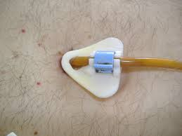](https://www.google.co.uk/imgres?imgurl=https://upload.wikimedia.org/wikipedia/commons/4/42/PEG_01.jpg&imgrefurl=https://en.wikipedia.org/wiki/Percutaneous_endoscopic_gastrostomy&h=750&w=1000&tbnid=kR9CJ2zfXnDglM:&docid=xzJj0U3LtGpcQM&ei=xAv4VZX0KoP-aLKbgIAF&tbm=isch&ved=0CFYQMygsMCxqFQoTCJXmyIyC-ccCFQM_Ggodsg0AUA)

**Who looks after the PEG tube?**

It is important to consider this before the tube is placed. Giving feed and medications through the tube and care of the tube require daily attention. Some individuals manage the tube feed themselves, while others need support from relatives, carers and health care professionals.

**What are the potential benefits and problems?**

Difficulty swallowing can become distressing for all concerned. A PEG tube can remove the anxiety which often accompanies meals and will allow you to obtain all the nutrition and hydration you require. Once the tube has been placed you may experience one or more of the following problems; blockages, infection, displacement, diarrhoea, constipation, nausea and vomiting. However with adequate care and attention, these can be avoided and are easily treated.

**Who will discuss PEG placement with me?**

The decision to have a PEG will be discussed with you by the medical team. If you decide not to have a PEG fitted, a Speech and Language Therapist will advise you on Eating and Drinking at Risk in order to minimise risk from oral diet and fluids. To discuss this further, please speak with the Speech and Language Therapist on the ward.

This information is available in audio, Braille, large print and other languages.   
To request a copy, please ask a member of staff.

Reviewed by Readers’ Panel October 2016.   
  
Printed December 2016 Review December 2018 Ref: DCS/SLT/0091216

## PEG REFERRAL FORM

**ENSURE ELECTRONIC REQUEST HAS BEEN COMPLETED:** [**http://lhapps:1106/**](http://lhapps:1106/) **COMPLETE FORM BELOW AND FILE IN PATIENT MEDICAL NOTES**

If the patient does not have capacity to make an informed decision about the insertion of a PEG, the decision to should be made by the patient’s multidisciplinary team led by the consultant or GP; in consultation with patient’s family/ carers. Patient should be known to each member of the MDT below, PRIOR to this referral being sent to Endoscopy.

* Consultant
* Dietetics
* Speech and Language therapy

Each case should be discussed individually and should take into account the patient’s wishes and their welfare.

***The aim of a PEG is to improve or maintain the quality of life of the patient and the potential benefits should outweigh the longer-term consequences. Please refer to the trust enteral feeding guidelines.***

**Patients MUST have had a capacity assessment prior to this referral being sent. If the patient is not known Speech and Language Therapy and Dietetics this referral will**

|  |  |
| --- | --- |
| **Inpatient**  Patient Sticker | **Outpatient/Community Patient**  Surname:  Forename:  DOB:  Address: |
| Consultant: | GP: |
| Referring Doctor:  Bleep: | GP address: |
| Ward: | Telephone Number: |
| Is an assessment required by a Consultant Gastroenterologist/ Surgeon prior to PEG insertion?  eg. If the patient has had a partial gastrectomy, or is to be considered for a jejunostomy/RIG?  Yes Date Referred: …………………… Referrer: ………………………….    No | |
| Has the patient been referred to Speech and Language Therapy ?  If no, refer to Speech and Language Therapy for assessment and advice.  Referral sent: ……………Signed:  If yes, what is the outcome of the swallow assessment?  Name of Speech and Language Therapist : | Has the patient been referred to the Dietetics?  If no, please refer to Dietetics for assessment and advice.  Referral sent: …………. . . . Signed:  If yes, name of Dietitian: |

**NOT be accepted by Endoscopy.**

|  |  |
| --- | --- |
| **Home circumstances** | |
| Have social and domestic circumstances been investigated? Are they satisfactory for tube feeding at home?  Yes/No  Signed:  Designation:  Date: | If no, investigation into home circumstances should be undertaken. If potential difficulties are identified, consider MDT/best interest meeting. |
| Is the patient capable of undertaking care of the feeding tube independently?  Yes/No  Signed:  Designation:  Date: | If no, determine/consider other options.  Comments: |
| Are family members or informal carers available to manage tube feeding if required?  Yes/No  Signed:  Designation:  Date: | If no, determine/consider other options.  Comments: |
| Has a care agency been identified to care for the tube feeding (if required)?  Yes/No  N/A  Signed:  Designation:  Date: | If no, liaise with social workers to identify appropriate care agency to create care package, or if needed consideration should be given to a nursing home.  Please contact dignitary matron where appropriate.  Comments: |
| Are arrangements in place regarding training for patient/family/carers on administering feed and medications via the tube?  Yes/No  Signed:  Designation:  Date: | If no, arrangements need to be made for patient/family/carers to receive this training. |

|  |  |  |
| --- | --- | --- |
| **Indications for PEG insertion (as per PEG guidelines)** | | |
| CVA | Motor Neurone Disease | Poor nutritional Status |
| Multiple sclerosis | Trauma | Head and Neck Cancer |
| Dysphagia | Pre radiotherapy/pre surgery | Learning disabilities |
| Anorexia or Cachexia | Obstructive lesion oesophagus | Other – please specify |
| Reason for PEG referral: | | |

|  |  |
| --- | --- |
| **Co morbidities/Contraindications** | |
| Cardiovascular | Abdominal Surgery |
| Diabetes | Abdominal Aortic Aneurysm |
| Malignancy | Respiratory |
| Ascites | Peritoneal Dialysis/Renal |
| Recent MI (within 6 weeks) | Other – specify |
| Co morbidities/contraindications: | |

|  |
| --- |
| **Multidisciplinary Decision** |
| Has a Best Interest Meeting discussion regarding PEG insertion taken place?  Yes No Date of MDT: ……………………………….  **MDT agrees that patient is suitable for PEG?**  **Yes No Date of decision: …………………………….**  (Best interest meeting signatures/designation below)  Has the concept of tube feeding been discussed with the patient/next of kin/family/carers/advocate? Including the risks/benefits? Has written literature (Is a PEG for me?) been provided for the patient and their family?  Yes No Date provided: ……………………………  If no, arrange meeting with patient/family/carers/advocate to discuss the pros/cons regarding ethical and quality of life issues.  Date of meeting ……………………………… Time of meeting …………………….. |

|  |  |  |  |
| --- | --- | --- | --- |
| **MDT Meeting** | | | |
| Attendees name printed: | Attendees Signature | Designation: | Bleep/Extension |
|  |  | Lead Consultant |  |
|  |  | Gastroenterology Consultant (if applicable) |  |
|  |  | Surgical Consultant (if applicable) |  |
|  |  | SLT |  |
|  |  | Dietitian |  |
|  |  | GP informed and agreed |  |
|  |  |  |  |

## DAILY CARE MONITORING OF LONG TERM FEEDING TUBES (PEG/PEJ/RIG/JEJ)

Patient Sticker

**PEG PEJ**

**RIG PEG – J**

**This document is to be completed for every patient who has a long term feeding tube in place for the administration of artificial nutrition and hydration and/or medication.**

**For Radiologically Inserted Gastrostomy (RIG) tubes & Jejunostomy (PEJ) feeding tubes please speak with the ward Dietitian.**

**For advice on problems that may occur at the start or during feeding, please see Problems and Troubleshooting in the Dysphagia Nutrition and Hydration Bundle.**

* The tube site requires daily cleaning with soap and water. It must then be dried thoroughly.
* PEG tube requires daily tube movement.
* The tube must be advanced (pushed 2-3cm into the stomach), retracted to the original position, and rotated through 360° daily from day 10 post insertion.

Month ……………………………………

**SIGN AND INITIAL ON COMPLETION**

|  |  |  |
| --- | --- | --- |
| Date | Movement | Cleaning |
| 1st |  |  |
| 2nd |  |  |
| 3rd |  |  |
| 4th |  |  |
| 5th |  |  |
| 6th |  |  |
| 7th |  |  |
| 8th |  |  |
| 9th |  |  |
| 10th |  |  |
| 11th |  |  |
| 12th |  |  |
| 13th |  |  |
| 14th |  |  |
| 15th |  |  |
| 16th |  |  |
| 17th |  |  |
| 18th |  |  |
| 19th |  |  |
| 20th |  |  |
| 21st |  |  |
| 22nd |  |  |
| 23rd |  |  |
| 24th |  |  |
| 25th |  |  |
| 26th |  |  |
| 27th |  |  |
| 28th |  |  |
| 29th |  |  |
| 30th |  |  |
| 31st |  |  |

**TOTAL PARENTERAL NUTRITION (TPN)   
(See Trust Parenteral Nutrition Guidelines)**

[**http://lhintra/trust-info/policies-guidelines-sops-and-pathways/policies-and-sops-download-page/?q=parenteral**](http://lhintra/trust-info/policies-guidelines-sops-and-pathways/policies-and-sops-download-page/?q=parenteral)

# TOTAL PARENTERAL NUTRITION